Hi Sunny –

The purpose of this next project will be to set up a postgres database on pythonanywhere that we will eventually use to support a webapp. I would like to rebuild my personal website and plan to have many graphics / widgets that use data from this database. We will get to the webapp at a later step, but I would like to first build the database and mechanism of updating it from my personal computer.

I currently have a paid pythonanywhere account but I have not upgraded it to include postgres capability. That will be step 1 – the account type will need to be changed to Custom with postgres enabled. The monthly cost will change but that’s ok. Feel free to choose whichever package and settings are necessary.

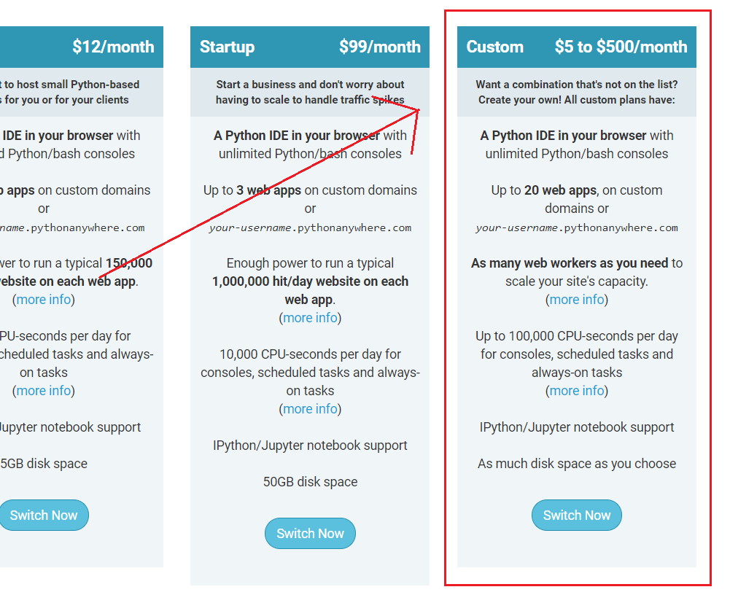

I put together a sample CSV file containing the data that I believe will be needed for the eventual webapp. What I’m hoping to accomplish is having a database table (or tables) created on pythonanywhere and just as importantly, have python functions made that I can use locally for updating the remote database (we can call these the CRUD functions). The python functions do not necessarily need to do all the functionality commonly included with a “CRUD” framework… but point being, my intention is to eventually update the database every day with new data that’s been calculated for the given day, so I’d like an easy way to do so from my local computer.

I have some experience with the python psycopg2 package… at least enough to know we could use it to create CRUD like functions to insert, delete, update, etc a remote postgres table on python anywhere?